**LAB 4**

**Objectives:**

* To learn how to do **Minimization of Boolean function using K-Map**

**EQUIPMENT:**  Logic trainer, Logic probe

**COMPONENTS**: ICs 74LS08, 74LS32, 74LS04

**Theory:**

**Minterm**

Each of the product terms in the canonical SOP form is called a minterm. Minterm are represented as binary numbers in terms of 0s and 1s. The binary words are formed by representing each non-complemented variable by 1 and each complemented variable by 0, and the decimal equivalent of this binary word is represented as a subscript of m **as** **m0, m1, m2,** etc. We generally use the **∑ (sigma)** notation to represent minterms.

**Maxterm**

Each of the sum terms in the canonical POS form is called a maxterm. Maxterm can also be represented using binary numbers where each non-complemented variable is represented using 0 and complemented variable using 1, and the decimal equivalent of this binary word is represented as a subscript of M **as M0, M2, M2,** etc. We generally use **∏ (pi)** notation to represent the max terms.

**Karnaugh map**

(K-map) is a method used to simplify Boolean expressions. K-Map is a grid-like representation of a truth table that gives more insight. . Optimal groups of 1s or 0s are identified, which represent the terms of a canonical form of the logic in the original truth table. The minimization will result in reduction of the number of gates (resulting from less number of terms) and the number of inputs per gate (resulting from less number of variables per term). The minimization will reduce cost and power consumption of the logic circuit.

**Q1. A. Fill Truth Table Using Logic Diagram, write Min Terms/ Max Terms from that.**

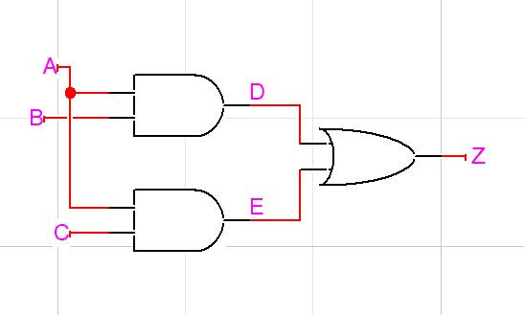

|  |  |  |  |  |  |  |  |
| --- | --- | --- | --- | --- | --- | --- | --- |
| A | B | C | D | E | Z(Final) | **Min Terms** | **Max Terms** |
| 0 | 0 | 0 |  |  |  |  |  |
| 0 | 0 | 1 |  |  |  |  |  |
| 0 | 1 | 0 |  |  |  |  |  |
| 0 | 1 | 1 |  |  |  |  |  |
| 1 | 0 | 0 |  |  |  |  |  |
| 1 | 0 | 1 |  |  |  |  |  |
| 1 | 1 | 0 |  |  |  |  |  |
| 1 | 1 | 1 |  |  |  |  |  |

**Q2. Write a following Function in terms of Min Terms/Max Terms and draw Truth table for implementation on Trainer.**

**F (A, B, C) = AB’C + AB'C' + ABC**

**SOLUTION:**

**Truth Table:**

**Q3. Do Minimizations of 4 Variables Boolean Functions Using K-MAP.**

* **A’B’C’D’ + A’BCD+ AB’C’D+ ABC’D’**

**K-MAP:**

**Diagram:**

* **F (A, B, C, D) = ∑m (1,3,4,5,9,11,14,15)**

**Write equation from function in POS form by K-MAP. Write Literal Cost and Gate Input Cost for this expression. Draw Truth Table and do implementation on Trainer.**

**Solution:**

**K-MAP**

**Truth Table:**